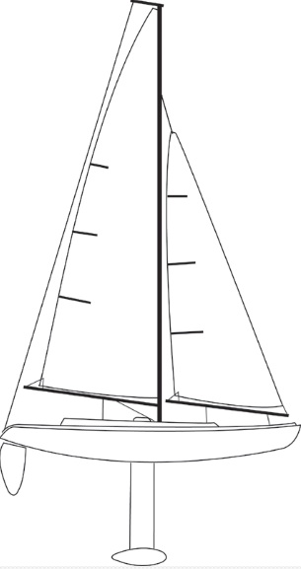2017 MEMBERSHIP APPLICATION
St. James Plantation
MODEL YACHT CLUB
(SJPMYC)
www.sjpmyc.weebly.com

PLEASE PRINT
DATE:

NAME:

FAMILY MEMBER:

ADDRESS:

SAIL NUMBER/HULL COLOR:________________________

PHONE: ________________________________________________

EMAIL:__________________________________________SPOUSE EMAIL_____________________________

AHOY, Membership in the St. James Plantation Model Yacht Club is open to anyone interested in participating and promoting Radio Control Sail boating. Membership dues are as follows:

An individual may register at a rate of $12.00 per year per adult or $20 for a Family Membership – Individual, spouse, children, grandchildren, etc.
Dues shall be used to support awards, club functions and equipment, etc.
Return this form and your payment to our Club Purser, making checks out to him.
Jim Taylor, 3415 Greenleaf Ct. St James.

